INFINITT PACS |  | INFINITT Product user tutorial | GTAC
 |  | INFINITT Product user tutorial | GST
General Description

This is a INFINITT PACS user tutorial

How to call INIFNITT Viewer from RIS/HIS
Overview
While using RIS/HIS to check patient information or report, user might need to read exam about the patient. Then user needs to log in PACS Viewer and search the patient information to read the exam. It causes user to feel inconvenient.
IFNINTIT PACS can solve this kind of problem. RIS/HIS enable to call INFINITT Viewer to read exam without logging in INFINITT Viewer again.

1 To call INFINITT Viewer
1. This tutorial is a guideline on the assumption that there is UI to call PACS from RIS/HIS
2. Basic URL to call INFINITT Viewer is below
http://IP address or computer name/pkg_pacs/external_interface.aspx?LID=%loginID%&LPW=%login
Password%&…..

3. For example, user needs to call exam with patient ID 001002 from HIS/ RIS
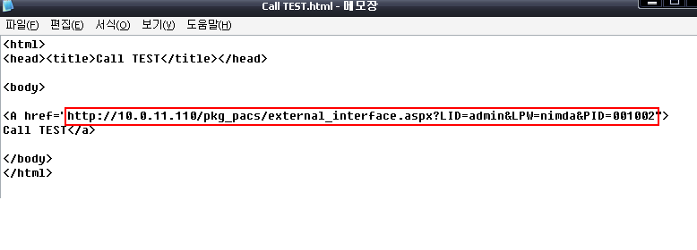
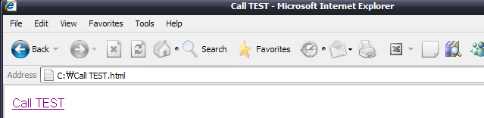

4. The URL calls the exam with patient ID 001002.
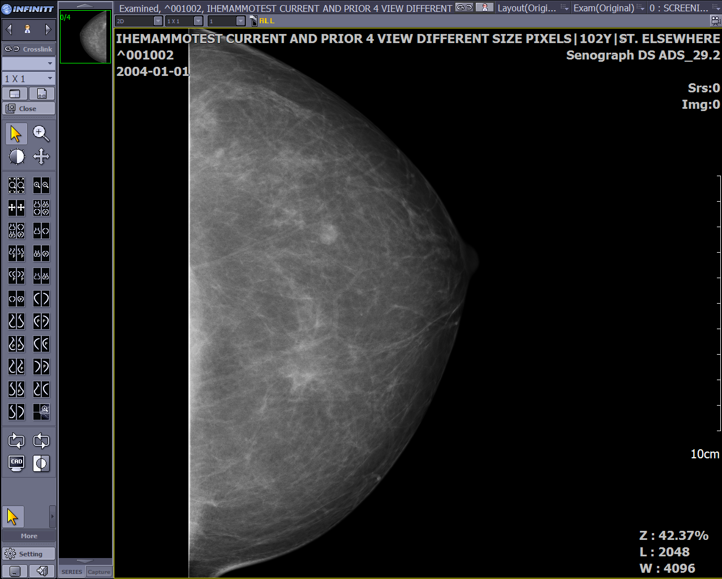

5. There are 12 kinds of field to call exam. You might use below information to modify URL to call PACS Viewer.
LID: Login ID
LPW: Login Password
MX: Max Number
PID: Patient ID
SID: Study ID
SEX: Patient Sex
NM: Patient Name
MDL: Modality
BP: Body Part
SD: Study DTTM
AN: Access Num
RD: Request Doctor

